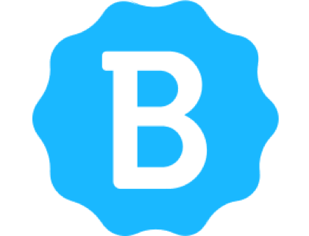

Betterteam Resume Template

[Full Name]
[Current job title, if applicable]
[Contact number] | [Professional email address] | [LinkedIn profile/website link]

Career Summary or Resume Objective
[Your career summary or resume objective.
A career summary is an overview of all your skills and work experience and is best used by experienced candidates. Resume objectives emphasize what you want to achieve in your career and may be used by new graduates or those transferring to a different career.]

Experience
(Current or most recent position first)

[Date of employment with year/month – year/month]
[Position Title]
[Company name and location]
- [2-4 bullet points, outlining your responsibilities and accomplishments]

[Employment dates xxx – xxx]
[Position xxxx]
[Company xxxxxxx]
- [Responsibilities xxxxxxx]
- [Accomplishments xxxxxx]

[Employment dates xxx – xxx]
[Position xxxx]
[Company xxxxxxx]
- [Responsibilities xxxxxxx]
- [Accomplishments xxxxxx]

Education
[School or institution name | Location (year started – year ended)]
[Degree name as well as majors/another relevant certificate]
[Special achievements or awards obtained]

[School xxxx | Location (xxx-xxx)]
[Degree xxx]
[Achievements/awards xxx]

[School xxxx | Location (xxx-xxx)]
[Degree xxx]
[Achievements/awards xxx]

Skills
- [Bulleted list of key skills, relevant to the position. Limit list to between 5 and 10 skills. Include both hard skills soft skills.]

